Madeline Merced

Project Documentation



# Executive Summary

This summary can be taken directly from the project design document. Proofread and edit the section so that it is appropriate for the final project documentation.

Goal Up is a goal setting and tracking application that helps users achieve their goals. This is done by drawing on a game-based point system that allows users to assign point values to every goal they enter. The totals will be calculated every day and stored in an easy to read graph(feature expected summer of 2019). This gives users the ability to simply review and evaluate their progress.

Goal Up is for users that are interested in personal development, achievement and personal growth. Applying an easy to understand point system gives users the opportunity to utilize some of most effective tools for personal growth backed by research. Studies have found that writing down your goals, setting clear objectives, reviewing them daily and having small daily rewards greatly increase the likelihood of one achieving their desired outcomes. Goal Up aims to integrate these tools into its simple, easy to use interface.

# Percentage Complete Summary

As of this writing Goal Up is about 80% complete. There are a few additional features that I’d like to add to enhance the user experience:

* Add a walkthrough form that gives users an overview of the system
* Store daily points total and date for use in a history page
* Provide a graph with values for users to review
* Allow users to customize profile
* Allow users to upload images

These features are expected to be completed by Summer 2019.

# Sign Up | Program Usage Description

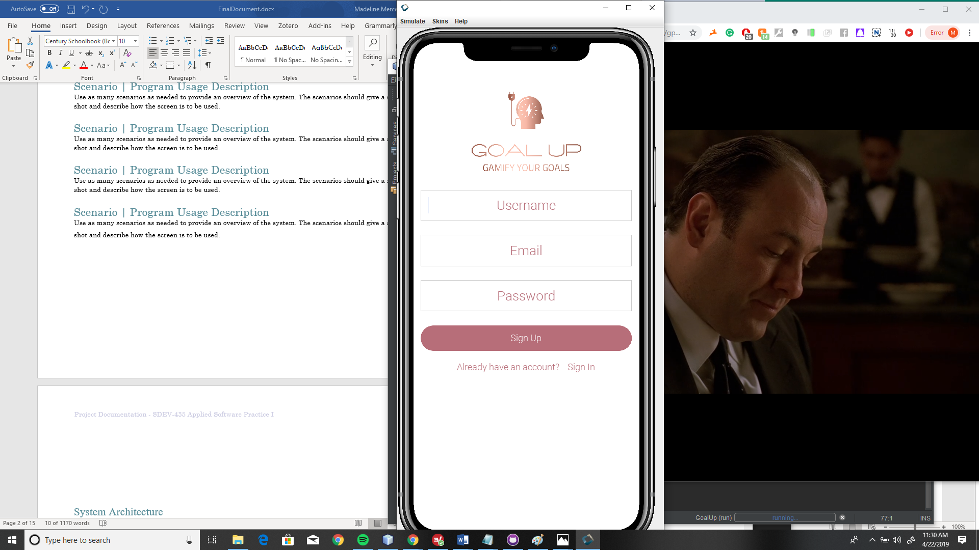

Sign up page that allows the user to enter a username, email and password. Also provides a link to the sign in page for users that already have an account.

# Sign In | Program Usage Description

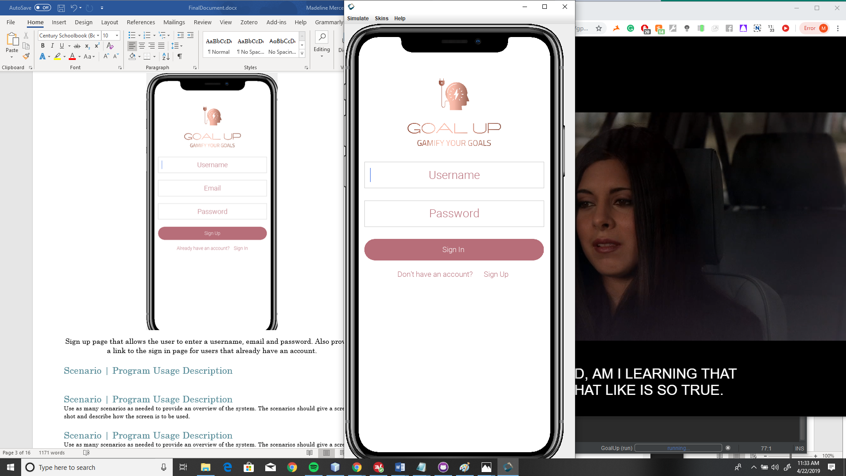

Sign in page that allows the user to enter their username and password. Also provides a link to the sign up page for users that need an account.

# Dashboard| Program Usage Description

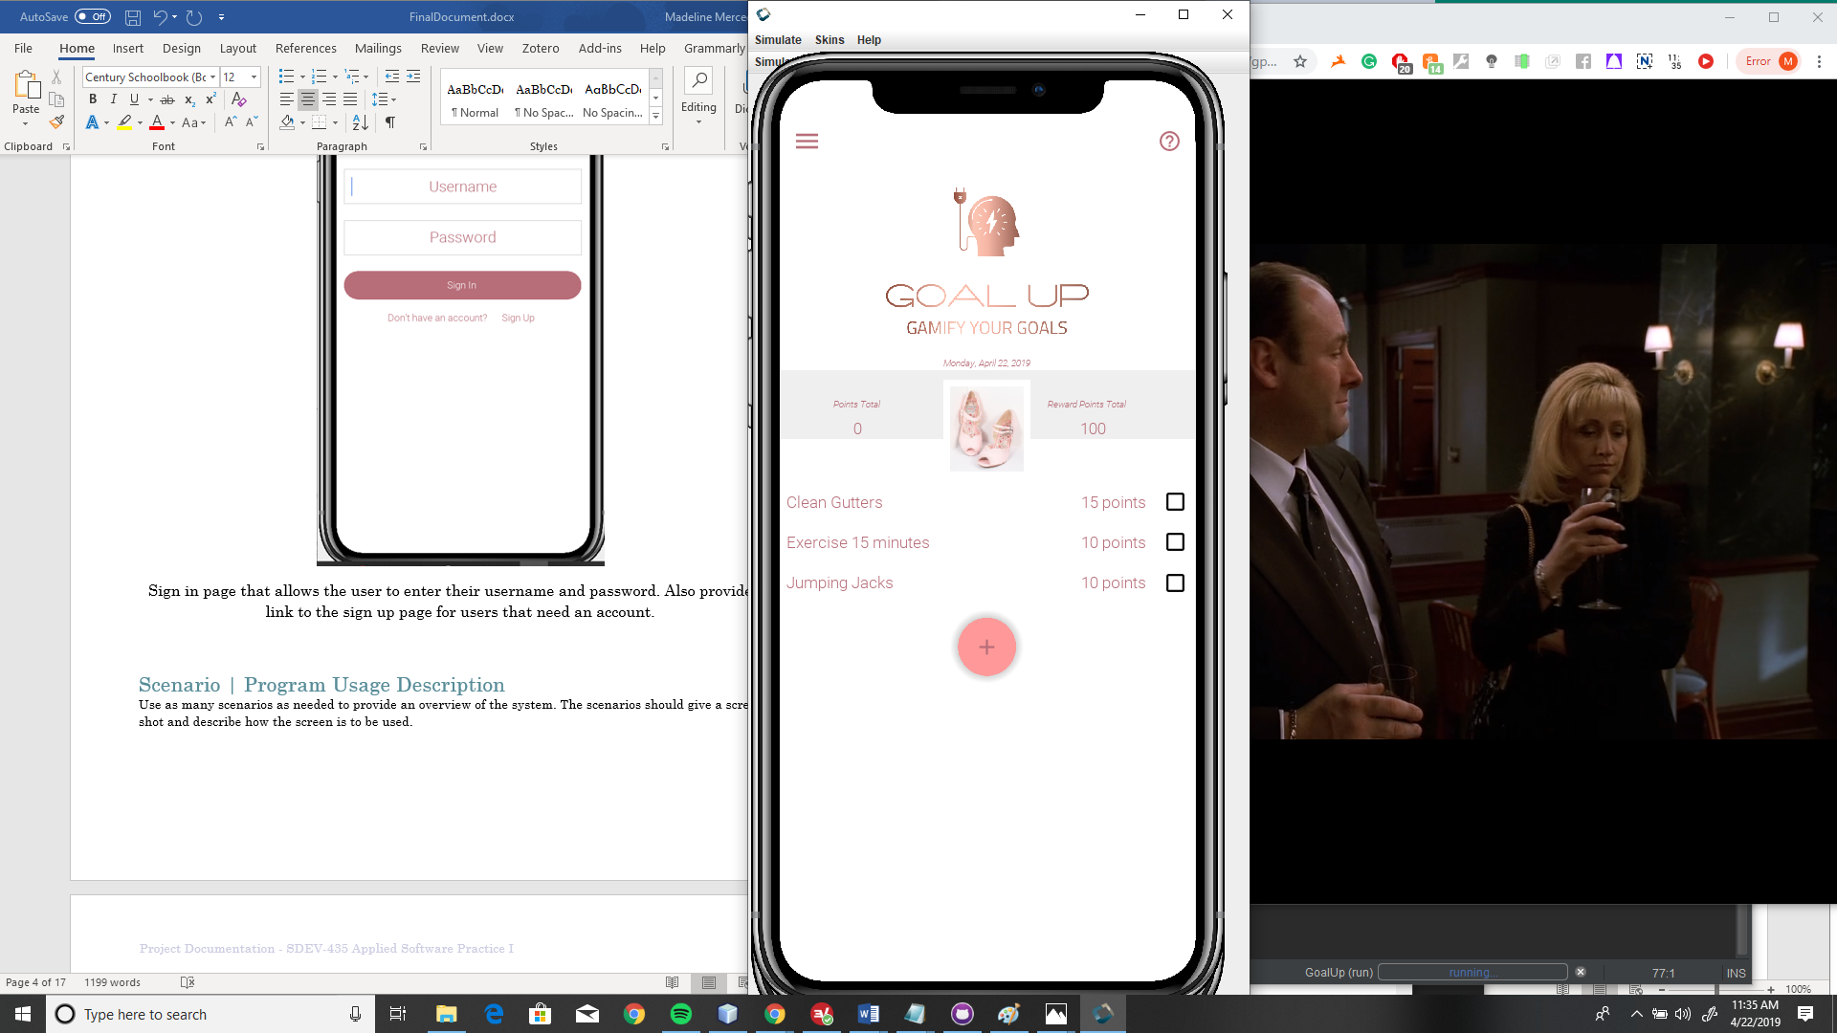

Dashboard page that displays goals with point values and checkbox for tracking points earned. Floating action button to add new goal or reward. Current date and point totals for earned and reward points.

# Popup Box | Program Usage Description

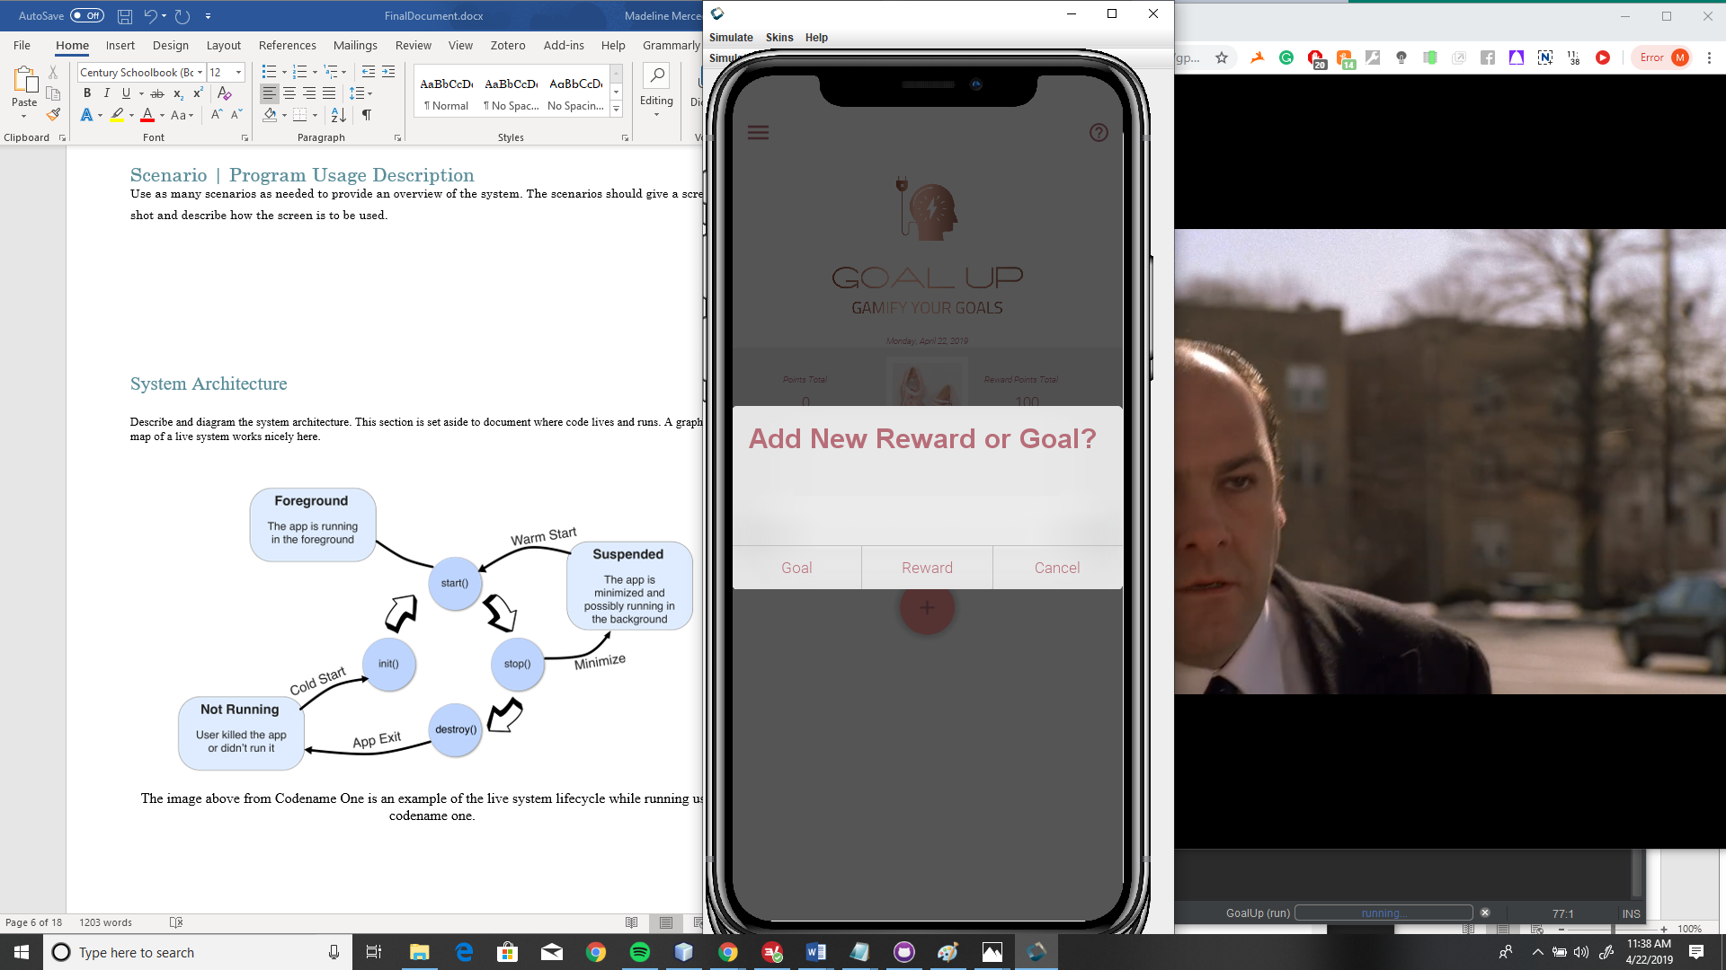

Popup dialog box after floating action button has been pressed that allows the user to add a new goal or new reward.

# Sign Up | Program Usage Description



Sign up page that allows the user to enter a username, email and password. Also provides a link to the sign in page for users that already have an account.

# Sign In | Program Usage Description



Sign in page that allows the user to enter their username and password. Also provides a link to the sign up page for users that need an account.

# Dashboard| Program Usage Description



Dashboard page that displays goals with point values and checkbox for tracking points earned. Floating action button to add new goal or reward. Current date and point totals for earned and reward points.

# Popup Box | Program Usage Description



Popup dialog box after floating action button has been pressed that allows the user to add a new goal or new reward.

# Add Goal | Program Usage Description

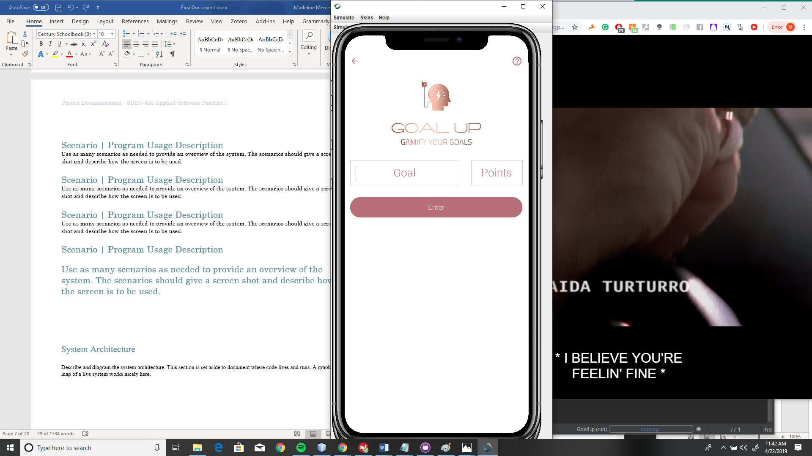

Allows user to add a new goal and point value to storage.

# Profile| Program Usage Description

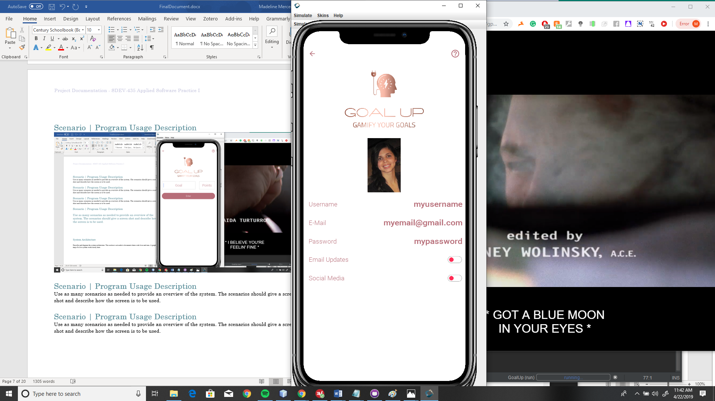

Profile page with user information.

# Goals | Program Usage Description

# 

Reads in from storage and lists goals.

# Rewards | Program Usage Description

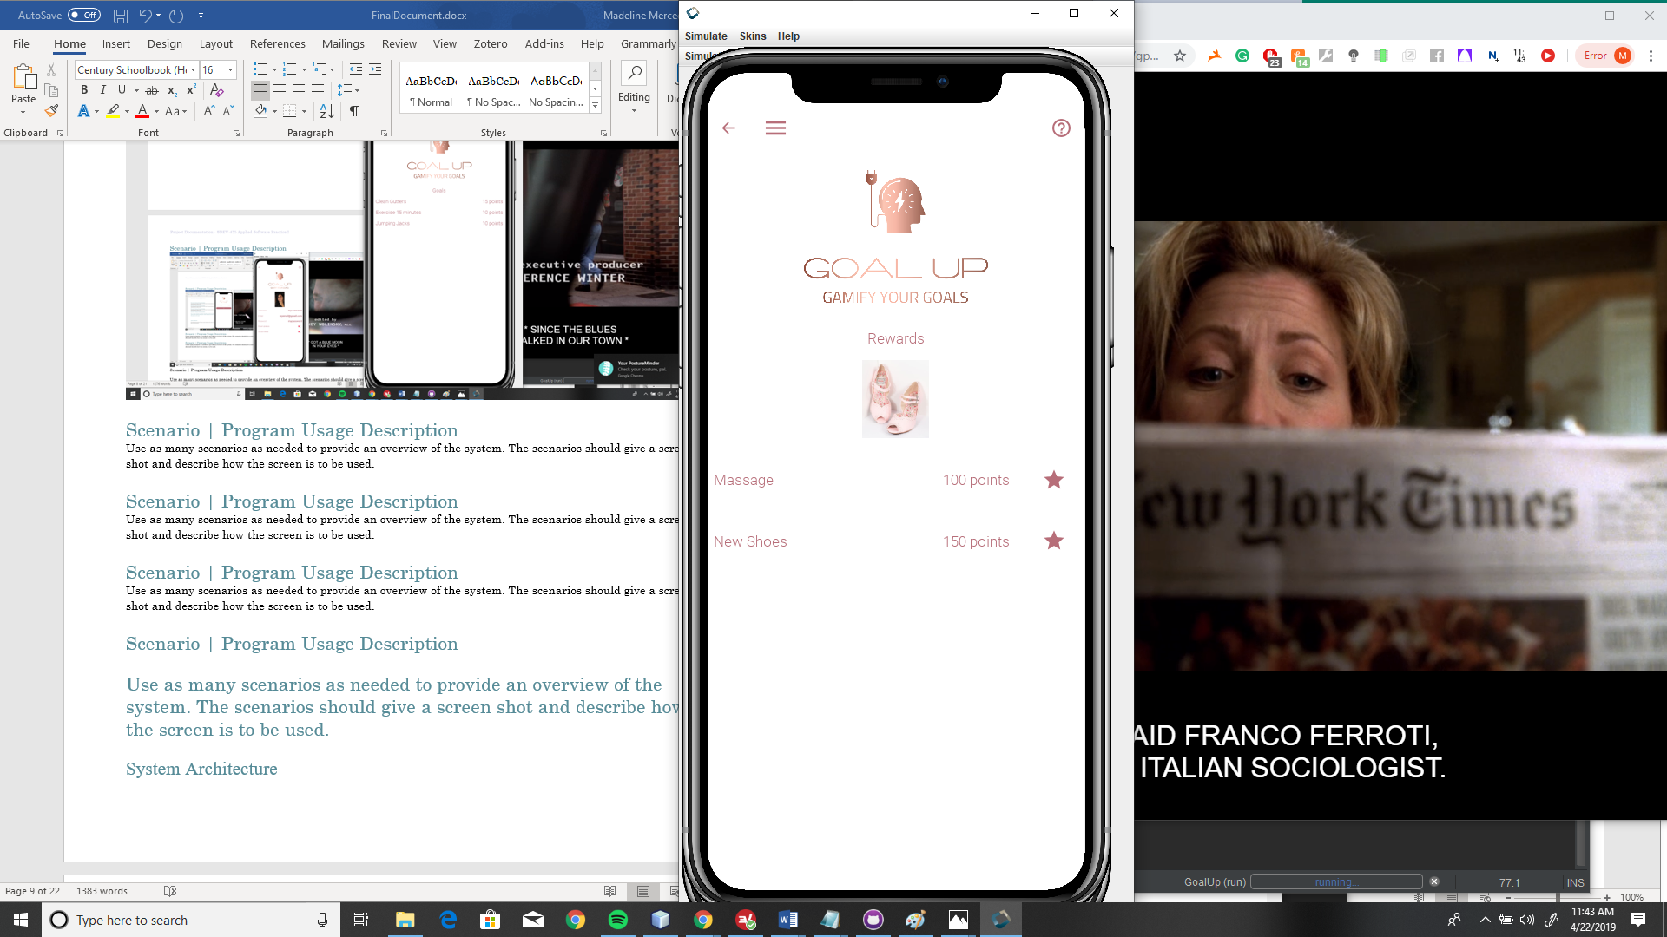

Reads in from storage to list rewards.

# Add Reward| Program Usage Description

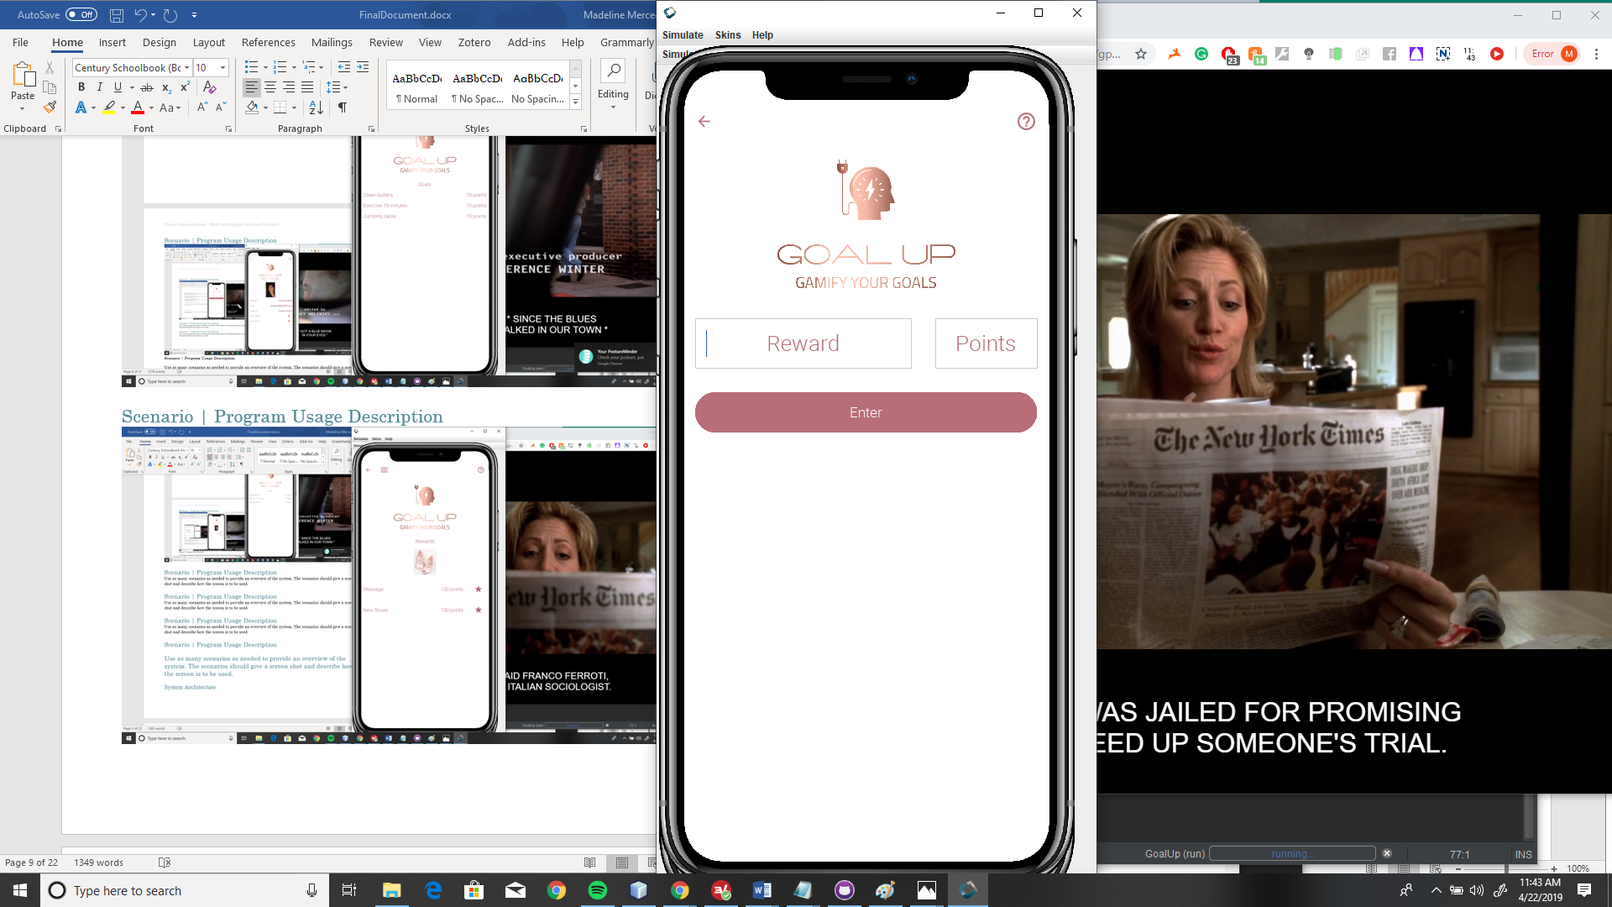

Allows user to add new reward and point value to storage.

# System Architecture

Describe and diagram the system architecture. This section is set aside to document where code lives and runs. A graphical map of a live system works nicely here.

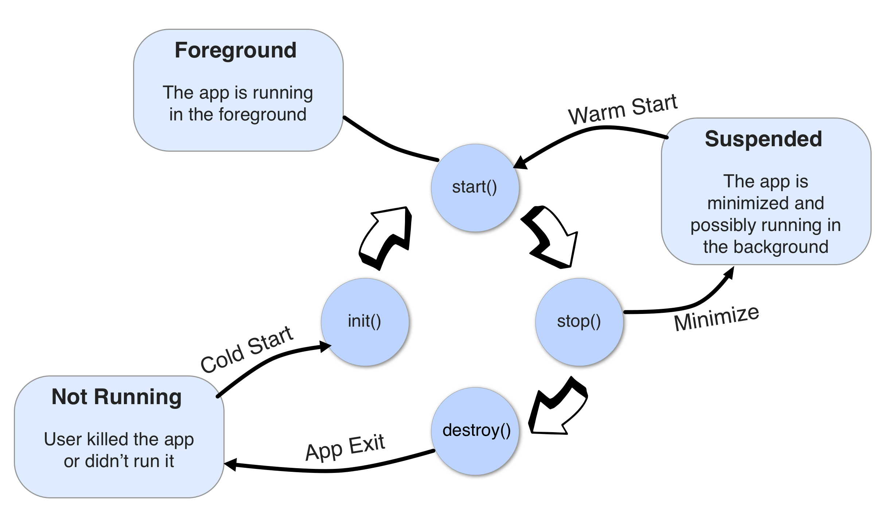

The image above from Codename One is an example of the live system lifecycle while running using codename one.

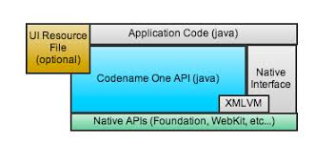

Example of application layers with the application code as a base, and then run through codename one into native APIs.

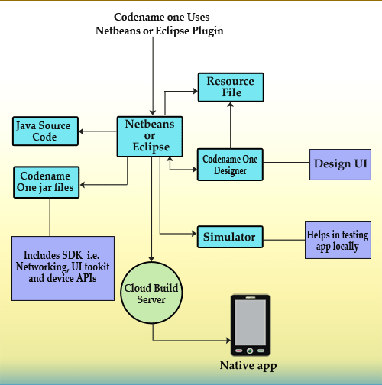

Diagram of Codename one lifecycle with specific files and directories.

# Code Architecture

Explain how the system is put together. Provide an introduction and then dig into the database or data store design and then explore the internals of the code.

The internal system for Goal Up is written in the Java programming language and Codename One library. The specific structures are outlined in the sections below.

## Source Code Structure

Source code structure introduction. The following is a summary of the source code directories and their contents:

|  |  |
| --- | --- |
| **Code Directory** | |
| **Directory** | **Usage** |
| Source Packages | <default package> , com.goalup.madelinemerced |
| com.goalup.madelinemerced | AddGoal.java  AddReward.java  BaseForm.java  CreateFileGoal.java  CreateFileReward.java  Dashboard.java  Goal.java  GoalUp.java  MyObject.java  Profile.java  Reward.java  SignIn.java  SignUp.java  VerifyValidate.java |
| Test Packages | Default package |
| Libraries | JavaSE.jar  CLDC11.jar  CodenameOne.jar  CodenameOne_SRC.zip  lib/impl/cls  lib/impl/stubs  native/internal_tmp  JDK 1.8(Default) |
| JavaSE.jar | Contains all of the codename one library sources |
| Test Libraries | JavaSE.jar |
|  | |

## Database or Data Store

Introduction to the database or data store.

Goal Up uses a flat file system as recommended by the developers at Codename One. The Storage class maps to Context.openFileInput(), is modifiable but does not support hierarchies. Every file is saved to the same folder (.cn1).

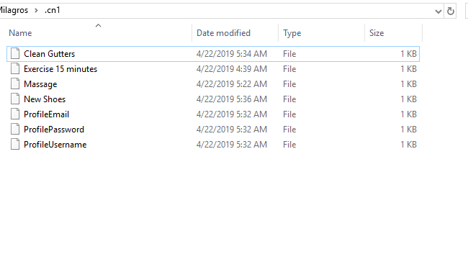

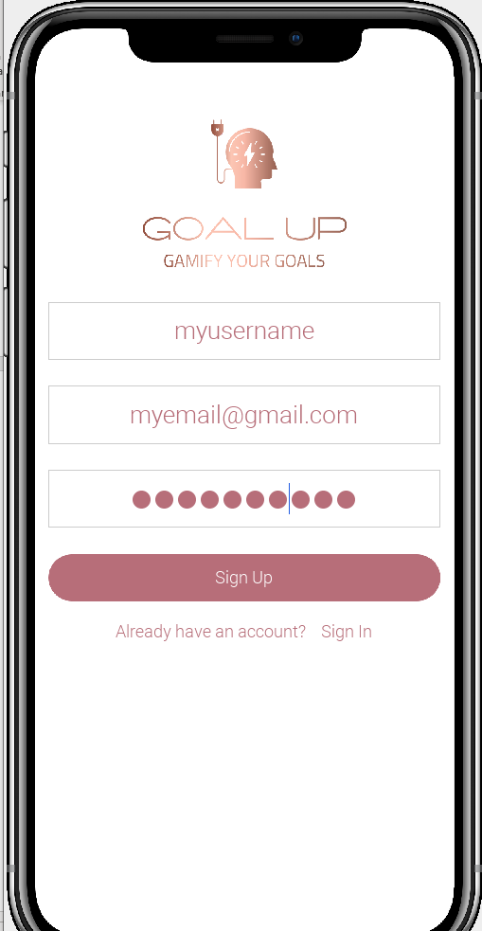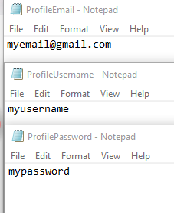

*An example of sign in form saving the information to the three profile files with the file contents changed.*

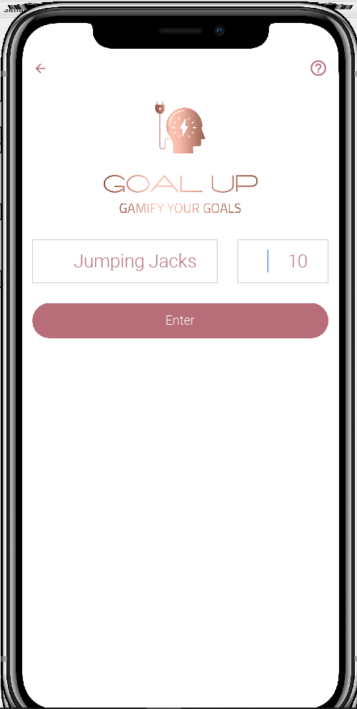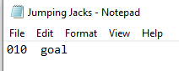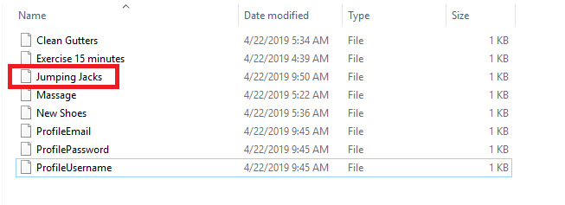

*An example of new data being written to storage and the contents.*

When the data is written, a simple text type is included to sort and display the file contents. These are split into three categories, “Profile”, “Goal” and “Reward”. The profile files are indicted by the predetermined names that are written to storage when the first user signup occurs. The goal and reward files are identified by the last entry in the file, either “goal” or “reward”.

External Files & Data

If any external files are used and/or if information is stored in the Registry, that information should be documented here. If this information needs security of some type that should be documented here as well.

Goal Up uses the Codename One Externalizable class to write and read objects in persistent storage. An example of the storage object registration is highlighted in the image below.

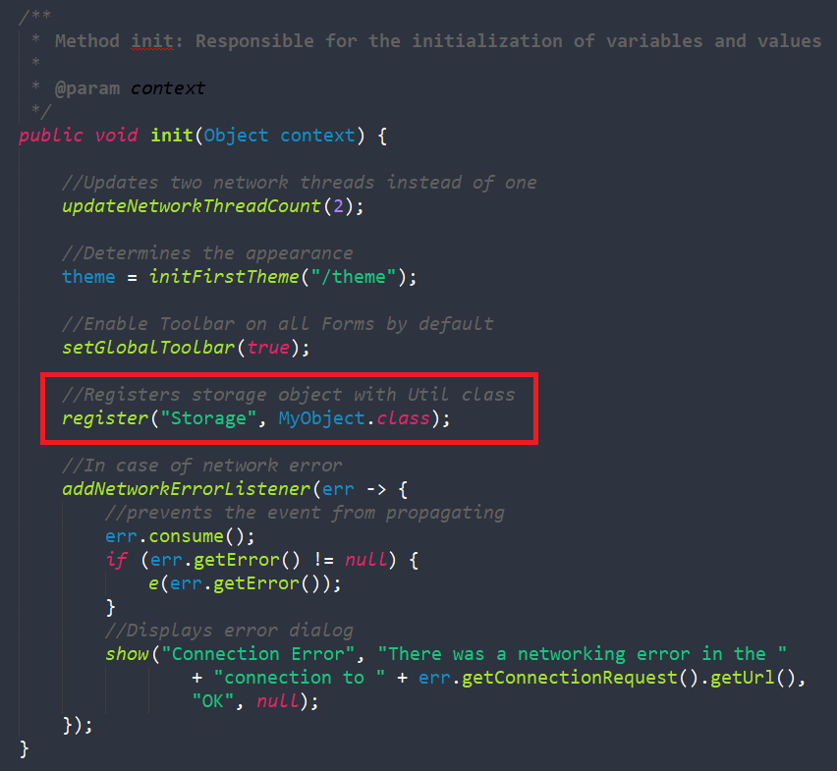

Programming Language | Java

Provide details about what language the project is written in. – Be sure to identify any components, references and/or external DLLS.

Goal Up is written in the Java programming language using the Codename One library for native mobile app development across the many mobile providers.

Project Classes

Classes within the project are used to abstract re-usable pieces of code. Classes are also used to group related values, known as properties. The project utilizes these classes:

### Adds Goal to Storage | AddGoal.java

### Creates form that takes user input and stores it to persistent storage.

### Adds Reward to Storage | AddReward.java

### Inherits Base Form properties to create form with text fields for entering reward details.

### Template for Project Forms | BaseForm.java

### Base Form extends Form class and provides project wide features for other subclasses.

### Returns Goal Storage Entries | CreateFileGoal.java

### Reads storage for goal entries and returns them formatted to the UI.

### Returns Reward Storage Entries |CreateFileReward.java

### Reads storage to return reward formatted files

### 

### Displays Dashboard Data | Dashboard.java

### Takes data from project classes and displays them to the dashboard.

### Displays Goals List | Goal.java

### Reads storage for goal files, formats and displays them on page

### Main Class | GoalUp.java

### Application main class that opens signUp page.

### Persistent Storage | MyObject.java

### Uses codename one externalizable class to save objects to persistent storage when called in subclasses

### Displays Profile | Profile.java

Displays user profile values to profile page.

### Displays Rewards List |Reward.java

### Reads storage for reward files, formats and displays them on page.

### User Sign In | SignIn.java

### Creates form that takes user sign in details.

### New User Sign Up |SignUp.java

### Creates form with text fields for new users to sign up.

### Alert Box | VerifyValidate.java

Returns alertBox when called

Summary

Goal Up was built using NetBeans, the Java programming language and Codename One. This system setup allows the application to be cross-platform in their respective native languages. Once the Java code is written, the build is shipped to Codename One where it is processed for shipping to the mobile app stores for the different devices.

The Goal Up application is built to allow users to create and save goals that they want to accomplish. These goals are saved with point values assigned by the user that are accumulated to reach the reward threshold. The rewards are also added by the users and the point values determine how much the user must accumulate to receive the reward. These tools are based on behavioral economic principles of goal setting, tracking and motivation.

# APPENDIX B (BUILD AND RELEASE PROCESS)

Describe the build & release process required to implement an update.

To build Goal Up, the developer must use NetBeans, Java and Codename One. The versions must be saved and updated according to Codename One recommendations.

# APPENDIX C (CLIENT INSTALLATION INSTRUCTIONS)

Detail how a client machine or device is prepared to utilize the project.

Once the application is made available in the app store, the user will visit the app store and download it to their device. They will use the sign up page to register for an account to begin tracking and storing their goal data.

# APPENDIX D (DEVELOPER SETUP INSTRUCTIONS)

Detail how a developer must setup their environment in order to work on the code.

A developer should be proficient in Java and familiar with Codename One. It is recommended that the developer utilize the NetBeans IDE with the Codename One plugin installed. It is also highly recommended that developers become familiar with the extensive Codename One library of videos and documentation to more effectively move through the process.

References

Codename One. (n.d.). File System, Storage, Network and Parsing. Retrieved April 21, 2019, from https://www.codenameone.com/manual/files-storage-networking.html

Codename One. (2019, April 12). Retrieved April 21, 2019, from https://www.codenameone.com/javadoc/com/codename1/io/Storage.html

Life Cycle Diagram. (n.d.). Retrieved April 21, 2019, from https://www.roseindia.net/iphone/comparing-the-various-open-source-java-iOS-tools.shtml